**Airport Consultants Council (ACC)**

**Pavement 101 Virtual Workshop**

**Group Exercise**

A midwest primary service medium hub airport has received a Bipartisan Infrastructure Law grant for $8.5M. They are looking to reconstruct Runway 7R/25L which had an area-weighted PCI of 62. The first phase of the project will be 3,900 linear feet of the runway denoted in red on the attached airport diagram. Future funding will be considered to rehabilitate the remainder of the runway. The primary runway at the airport is Runway 1L/19R

The owner has asked you to develop a recommendation for the pavement section to be designed for the runway reconstruction. Based on the aircraft fleet mix provided pavement sections have been designed and included. Perform a Life-cycle Cost Analysis and present recommendations based on a comprehensive analysis of all factors that could influence the choice of pavement section.

Use the given information to answer the following questions while performing your LCCA:

1. What would you recommend as a functional life for the flexible pavement? Rigid Pavement?

2. What analysis period would you choose for the LCCA? What discount rate?

3. Do either of your alternatives have a salvage value? If so what is it?

4. Develop a maintenance and rehabilitation strategy for each pavement alternative.

5. Determine the Present Worth of both pavement alternatives.

6. What are some other factors you would consider in selecting a preferred alternative to design?

**Airport Diagram**

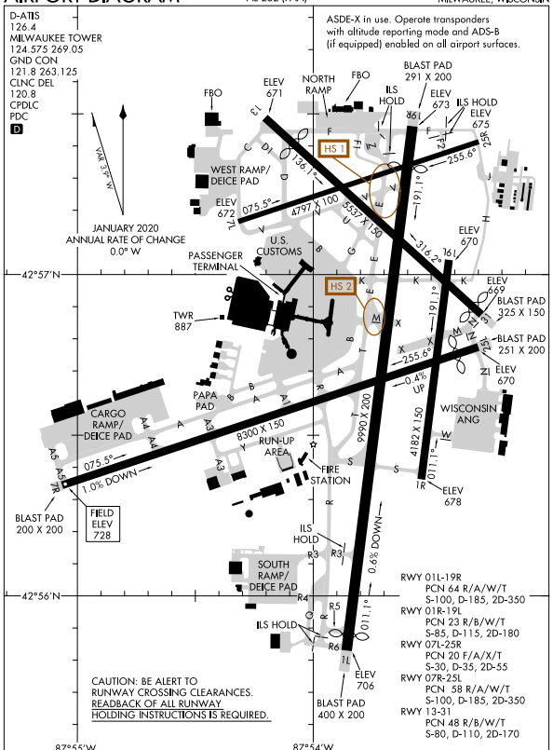

**Pavement Design Data**

Traffic Mix for Pavement design

|  |  |  |  |
| --- | --- | --- | --- |
| **Aircraft** | **Departure Weight, lbs** | **Annual Departures** | **Growth Rate, %** |
| Boeing 767-300 | 352,000 | 100 | 1.1 |
| Boeing 737-700 | 155,000 | 2,500 | 1.1 |
| Boeing 737-800 | 174,700 | 588 | 1.1 |
| Airbus A319-100 | 141,978 | 1,134 | 1.1 |
| Airbus A320-200 | 162,925 | 688 | 1.1 |
| Airbus A321-200 | 207,025 | 130 | 1.1 |
| MD83 | 161,000 | 954 | 1.1 |
| MD90-30 ER | 168,500 | 150 | 1.1 |
| CRJ-700 | 73,000 | 2,750 | 1.1 |
| CRJ-900 | 85,000 | 1,150 | 1.1 |
| EMB-170 | 79,697 | 2,250 | 1.1 |
| EMB-190 | 105,712 | 1,250 | 1.1 |
| Boeing 757-200 | 256,000 | 230 | 1.1 |
| Boeing 707-320C (KC-135) | 336,000 | 895 | 1.1 |

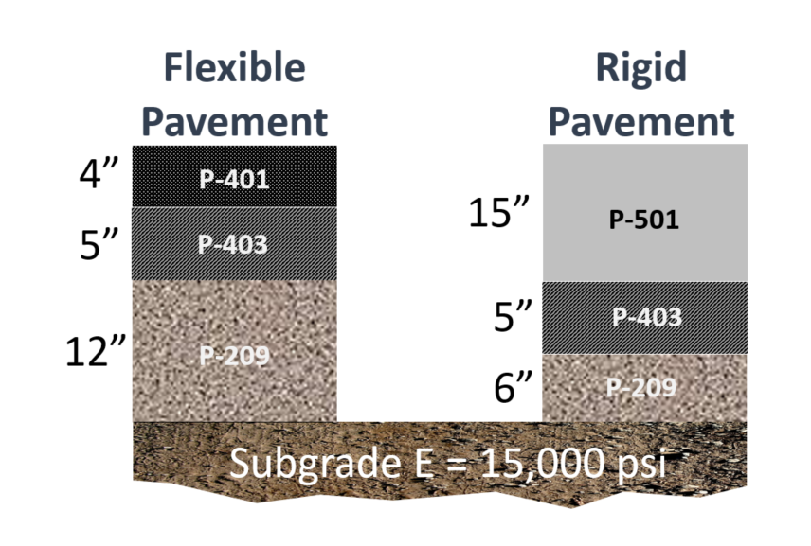

**Unit Costs for Construction, Maintenance and Repair Activities**

New Construction Unit Costs

|  |  |
| --- | --- |
| **Material Type** | **Unit Cost (yd2)** |
| P-209 – 12” | $32.00 |
| P-209 – 6” | $18.00 |
|  |  |
| P-403 – 5” | $31.50 |
| P-401 – 4” | $30.11 |
|  |  |
| P-501 – 15” | $72.95 |

Maintenance Unit Costs

|  |  |
| --- | --- |
| **Maintenance Activity** | **Unit Cost** |
| AC Crack Sealing | $1.45/ft |
| Full-depth AC Crack Repair | $28.00/ft |
| Partial-depth AC Patch | $6.50/sf |
| Full-Depth AC Patch | $10.50/sf |
| AC Surface Treatment | $1.85/sf |
|  |  |
| PCC Crack Sealing | $3.75/ft |
| Joint Sealing | $3.40/ft |
| Partial-depth PCC Patch | $230/sf |
| Full-depth PCC Patch | $20.00/sf |
| Slab Replacement | $25.00/sf |
| Grinding | $7.43/ft |

Major Rehabilitation Unit Costs for Flexible Pavement

|  |  |
| --- | --- |
| **PCI Range** | **Unit Cost** |
| 0 – 40 | $16.00/sf |
| 40 – 50 | $9.50/sf |
| 50 – 60 | $7.50/sf |
| 60 – 70 | $4.50/sf |
| 70 – 80 | $4.50/sf |

Major Rehabilitation Unit Costs for Rigid Pavement

|  |  |
| --- | --- |
| **PCI Range** | **Unit Cost** |
| 0 – 40 | $17.75/sf |
| 40 – 50 | $15.50/sf |
| 50 – 60 | $13.50/sf |
| 60 – 70 | $13.50/sf |
| 70 – 80 | $13.50/sf |